|  |  |
| --- | --- |
| Bluetooth Support for RetroConnector Keyboard Interface IIe  BLUETOOTH Keyboard | Apple II Forever |

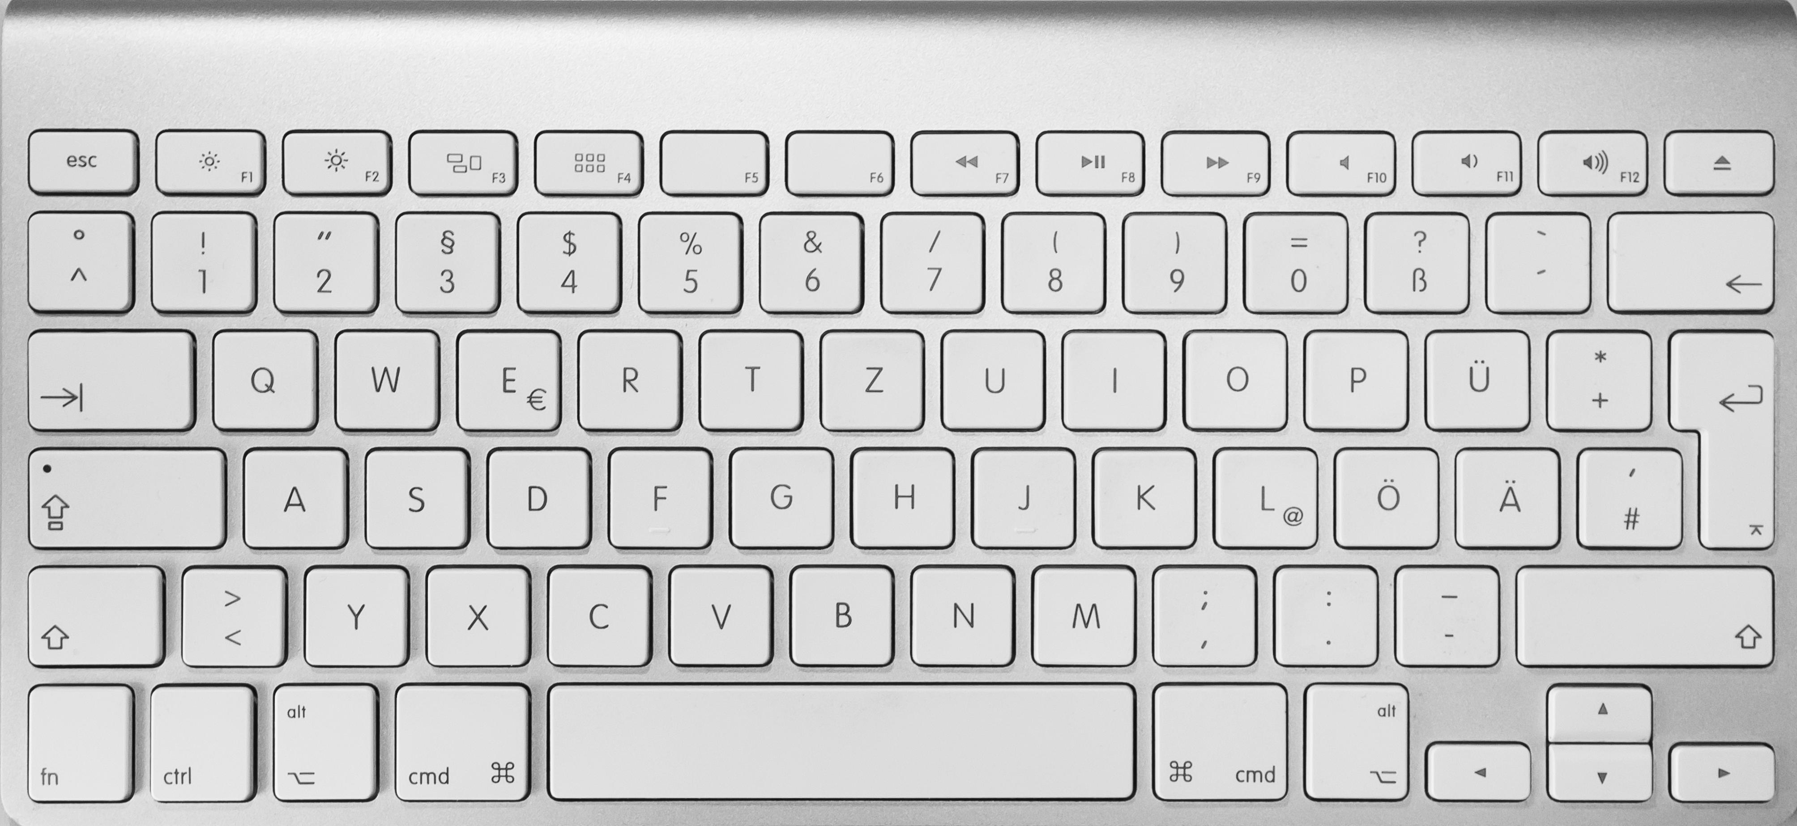

This connects in line with an Apple IIe keyboard and allows you to pair to a Bluetooth keyboard.

Note: this has been tested with a few Bluetooth keyboards and each responded slightly different. As such this is considered ‘best effort’ firmware.

**There are 3 Buttons on the RetroConnector board:**  
  1) Closed Apple  
  2) CTRL + Reset  
~~3) Bluetooth Pairing - MUST BE DONE IN FIRST 5 SECONDS - Hold down the button to put the card into pairing mode.  You will see the Bluetooth Dongle light blink.  
 (after 5 seconds the card will attempt to connect to last pair/saved device)~~

Note: This has not been implemented in this firmware - Most Bluetooth keyboards failed to reconnect, as such the board will always go into pairing mode and require the keyboard to be paired each time it is used. You do not need to press this button each time.

**Sequence to enable:**

* Turn on the Apple IIe
* The blue light on the Bluetooth dongle will begin to flash steadily
* Place Keyboard into BT Pairing mode (different for every keyboard)
* Type ‘0000’, and then ENTER on the keyboard
* Keyboard will pair and connect and you can start to use it.

Some buttons on the keyboard might not function as desired.

* Caps Lock – might not work and keys are in lower case. Shift seemed to work in all cases.
* F1-F12 buttons – F12 is mapped to CTRL-DEL. However, on some keyboards F12 wasn’t working.

Enjoy!

The firmware code is available on GitHub and can be modified. To modify yourself an Arduino AVR programmer is required to write onto the ATMEGA 328p chipset.